BCeID Comms Team Upcoming items:
Updated: April 4, 2025
Prepared by: Doug Corkery
- Pre-Go Live - email - Send Tue/Wed. April 8 – send to our existing same email list we sent to the previous emails – content is to remind that cutover is happening last chance to update emails in BCeID
  - Option - HC Ops Bulletin ? Send at same message time with the April 8 (Pre go Live) and a Post Go – Live notice
- Password Reset Emails – April 14 - - Email to migrated account holders - Activate your WorkSafeBC online services account.docx
Regarding the Password Reset Process:
- Email Messaging:
  - Create the password reset email messaging.
  - Review wording with Garima’s team to ensure it emulates ForgeRock standards.
  - Develop the email template.
- Dynamics Loading:
  - Load the emails into the Dynamics environment with David Dong on Thursday, April 10th.
- Timing Email List Coordination:
  - Coordinate the retrieval of the updated email list from BCeID.
  - Confirm who handover of the email list and when it will be received (Friday, April 11th).
  - Load the email list into Dynamics and send the email on Saturday, April 12th in the morning.
  - Determine the exact time for handoff to Dynamics for loading.
- Bulk Email Sending:
  - Schedule the bulk password reset email for Saturday, April 12th. Current eta, if all goes to plan 10-11am.
  - Ensure synchronization with Paul (PCIS) converting the Portal login screen to the WorkSafeBC login screen.
  - Confirm if David Dong is the only resource available to send the email and if he is available on Saturday morning. Can Doug control this process?
Password Reset - Link - ForgotPassword  This is what a user receives in their inbox when requesting a PWD reset | This is the UI screen - Notification if a user is not registered  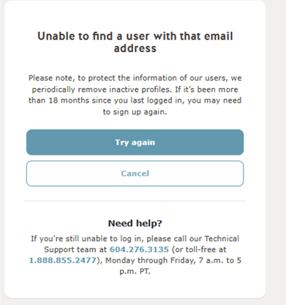

- April 10 – content delivery to PCIS – for Posting on Friday Apr. 11. - Advise PCIS to Post go-live (insert a banner) at Portal login screen Login – remind to use their Emal address on the WorkSafeBC online services login screen that they provided in their BCeID account update. AND include instructions to Stragglers that after BCeID has been replaced with the worksafebc.com account login on April 13 you will need to self-register on worksafebc.com. To do so, please follow these steps:
  - Limits – Target 2000 characters max must be <3000 characters (w/ embedded formatting)

  - Include Link to Provider Portal changing from BCeID to WorkSafeBC account login | WorkSafeBC
  - Create your account at online.worksafebc.com.
  - Update your BCeID account at Log in to Manage Account with the same email address as your preferred contact method, following the steps outlined above.
  - Allow 2 to 5 business days for your account to be created. Your Provider Organization Administrator you will receive a confirmation email once the account has been created instructing you to visit ForgotPassword page and enter your email address you used to create your account at online.worksafebc.com. A link will be sent to you to set your password and you will be provisioned to access the Provider Portal.
  - If you encounter access issues after this period, please contact HCPSupport@worksafebc.com.

Draft - Telus CPR Banner Content - Provider BCeID Migration to WorkSafeBC Account.docx

- THS Call Line PBX - Uploaded a primer - Telus IVR Call Script.docx – to be implemented by April 11
- Post go-live transition – Optional email & (HC Ops Bulletin options) - Draft – P. 7 - #4 - Advisory Email Content to Providers_Admins - Provider BCeID Migration to WorkSafeBC Account.docx
  - Stragglers Process:
  - Start the process for stragglers on Monday, April 14th.
  - Lyle confirmed no need for multiple password reset messages for stragglers post-April 13th, as they will create their accounts directly on the WorkSafeBC login screen.
- Web Site Consolidations – Initial Draft Potential Website Changes (draft).docx – ETA – focus post implementation. - Target Landing Page - Online billing options - WorkSafeBC
    - Content Creation
    - Links lined up
    - Publication Workflow - staging to prod with Web Services
Stakeholders
- Business – HC Ops (Anna Lam), Program
- Product alignment - Harm, Khushboo,
- Comms – Kieran
- Web Services, Trevor / Anne – Traffic links incoming and outgoing
- Project Team –Diane, Doug

